Executing instance methods: Step-by-step exercises
In this exercise, you will use the Terminate instance method from the Win32_Process WMI class. This provides practice calling WMI instance methods. In the next exercise, you will practice calling static class methods.
Stopping several instances of a process by using WMI
1. Log on to your computer with a user account that does not have administrator rights.
2. Open the Windows PowerShell console.
3. Start five copies of Notepad.

Insert command and screen shot of results

4. Use the Get-WmiObject cmdlet to retrieve all instances of the notepad.exe process.
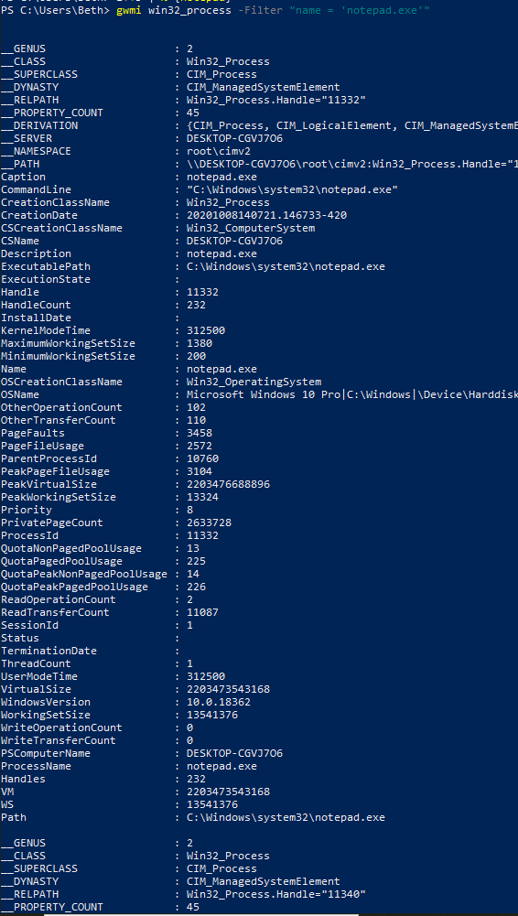
Insert command and screen shot of results

5. Now pipeline the resulting objects to the Remove-WmiObject cmdlet.
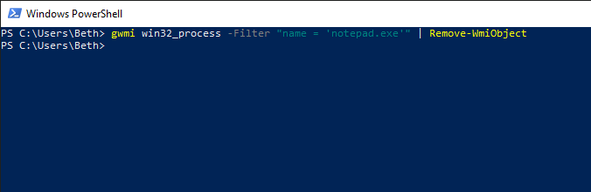
Insert command and screen shot of results

6. Start five instances of Notepad.
Insert command and screen shot of results

7. Use the Up Arrow key to retrieve the Get-WmiObject command that retrieves all instances of notepad.exe.

Insert command and screen shot of results

8. Store the returned WMI objects in a variable named $process.
Insert command and screen shot of results

9. Call the Terminate method from the $process variable.
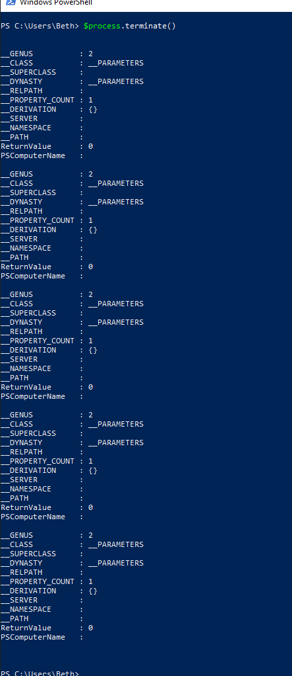
Insert command and screen shot of results

10. Start five copies of Notepad back up. The command appears here.
1..5 | % {notepad}
11. Use the Up Arrow key to retrieve the Get-WmiObject command that retrieves all instances of notepad.exe.
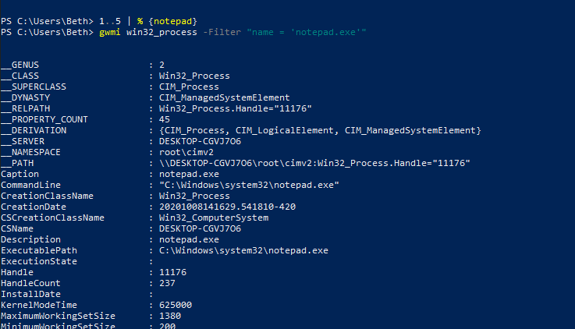
Insert command and screen shot of results

12. Call the Terminate method from the previous expression. Put parentheses around the expression, and use dotted notation to call the method.
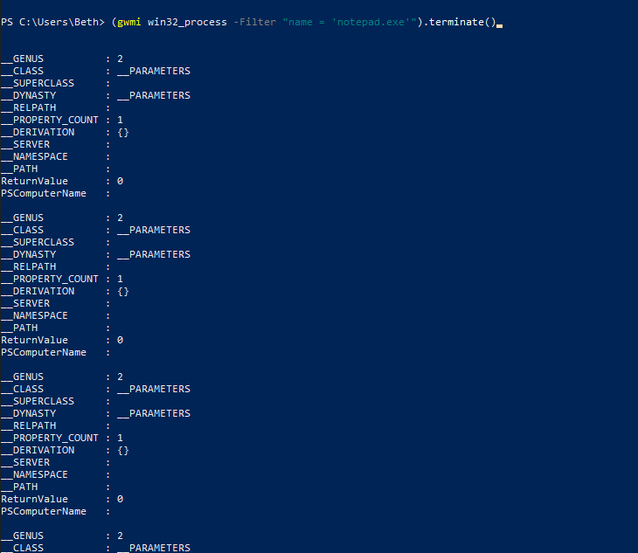
Insert command and screen shot of results

This concludes the exercise.

